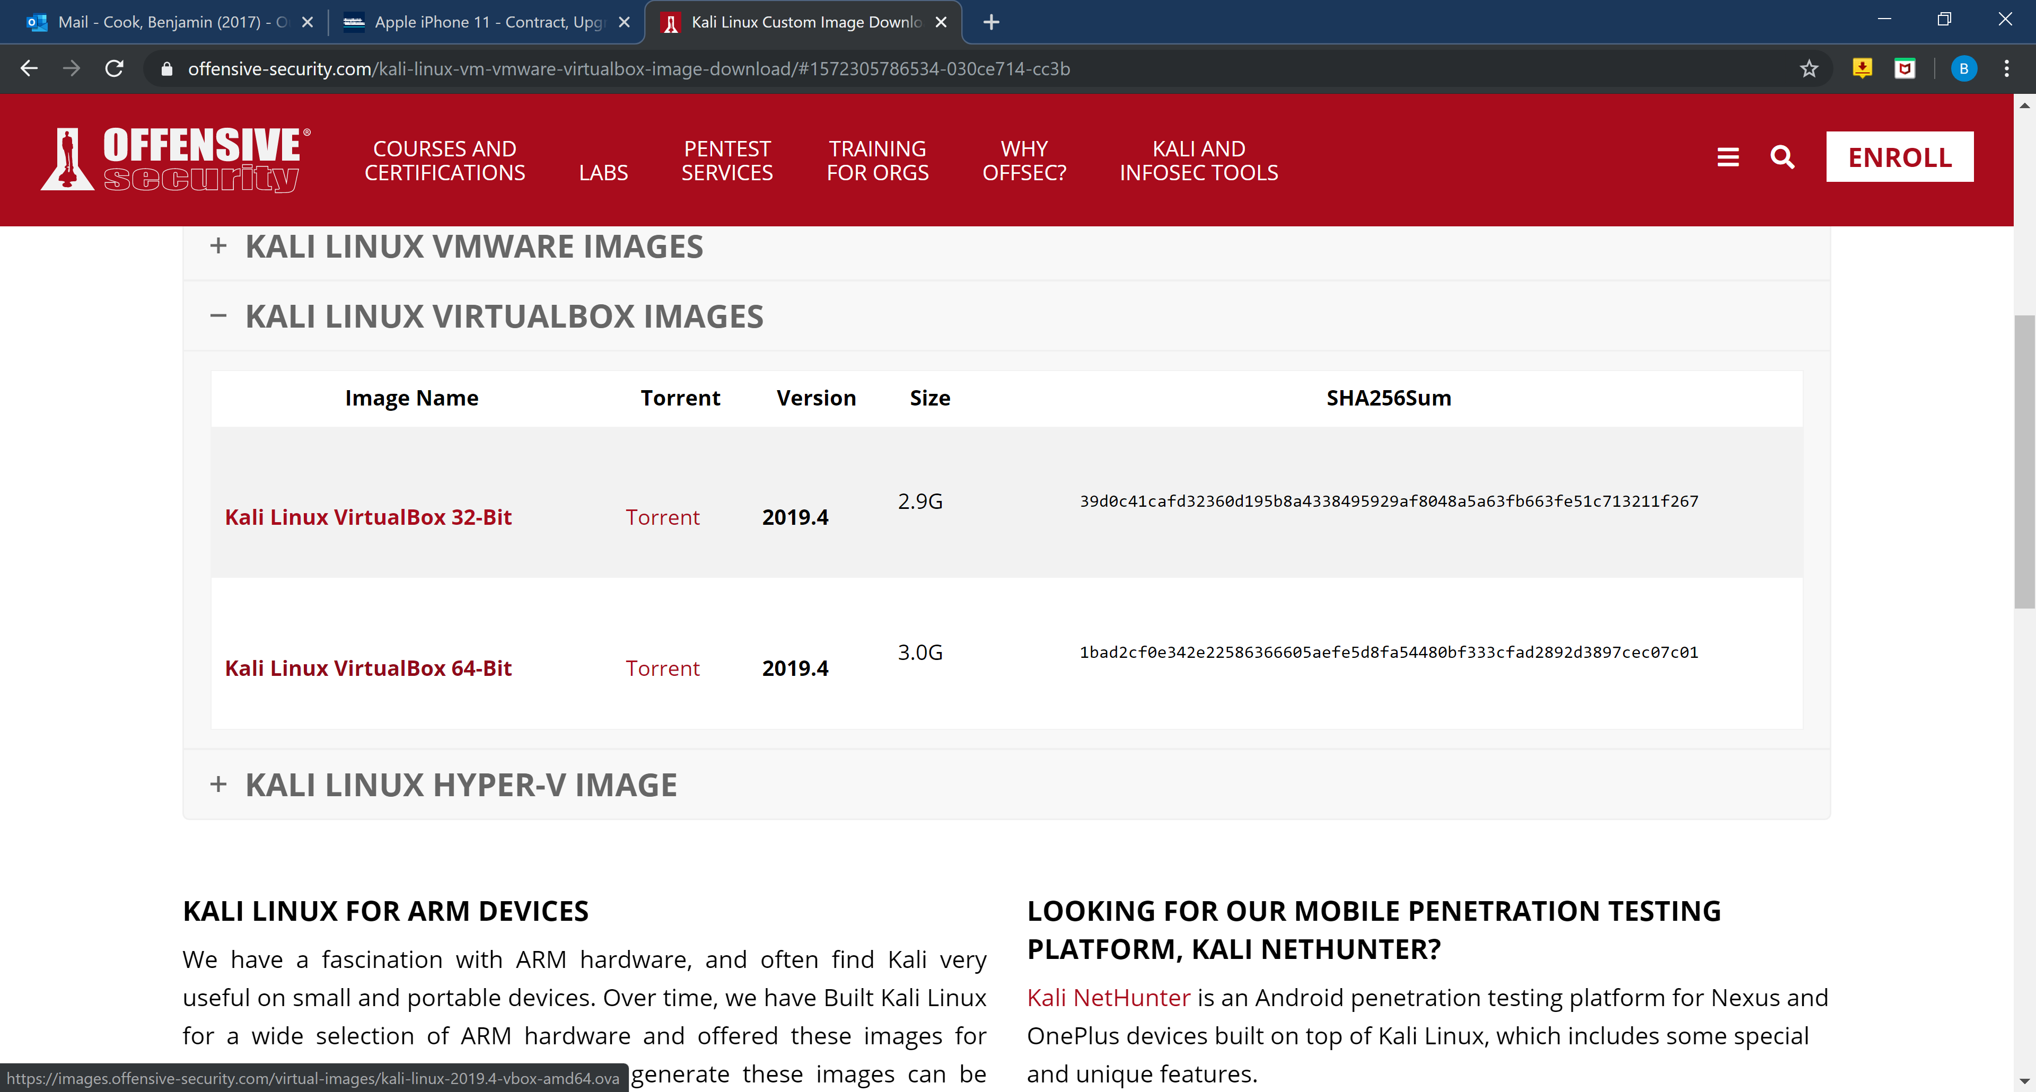

I first downloaded the Virtual Machine Image from the Kali Linux website. Then installed it onto my system and added it to my Virtual Box by importing it.

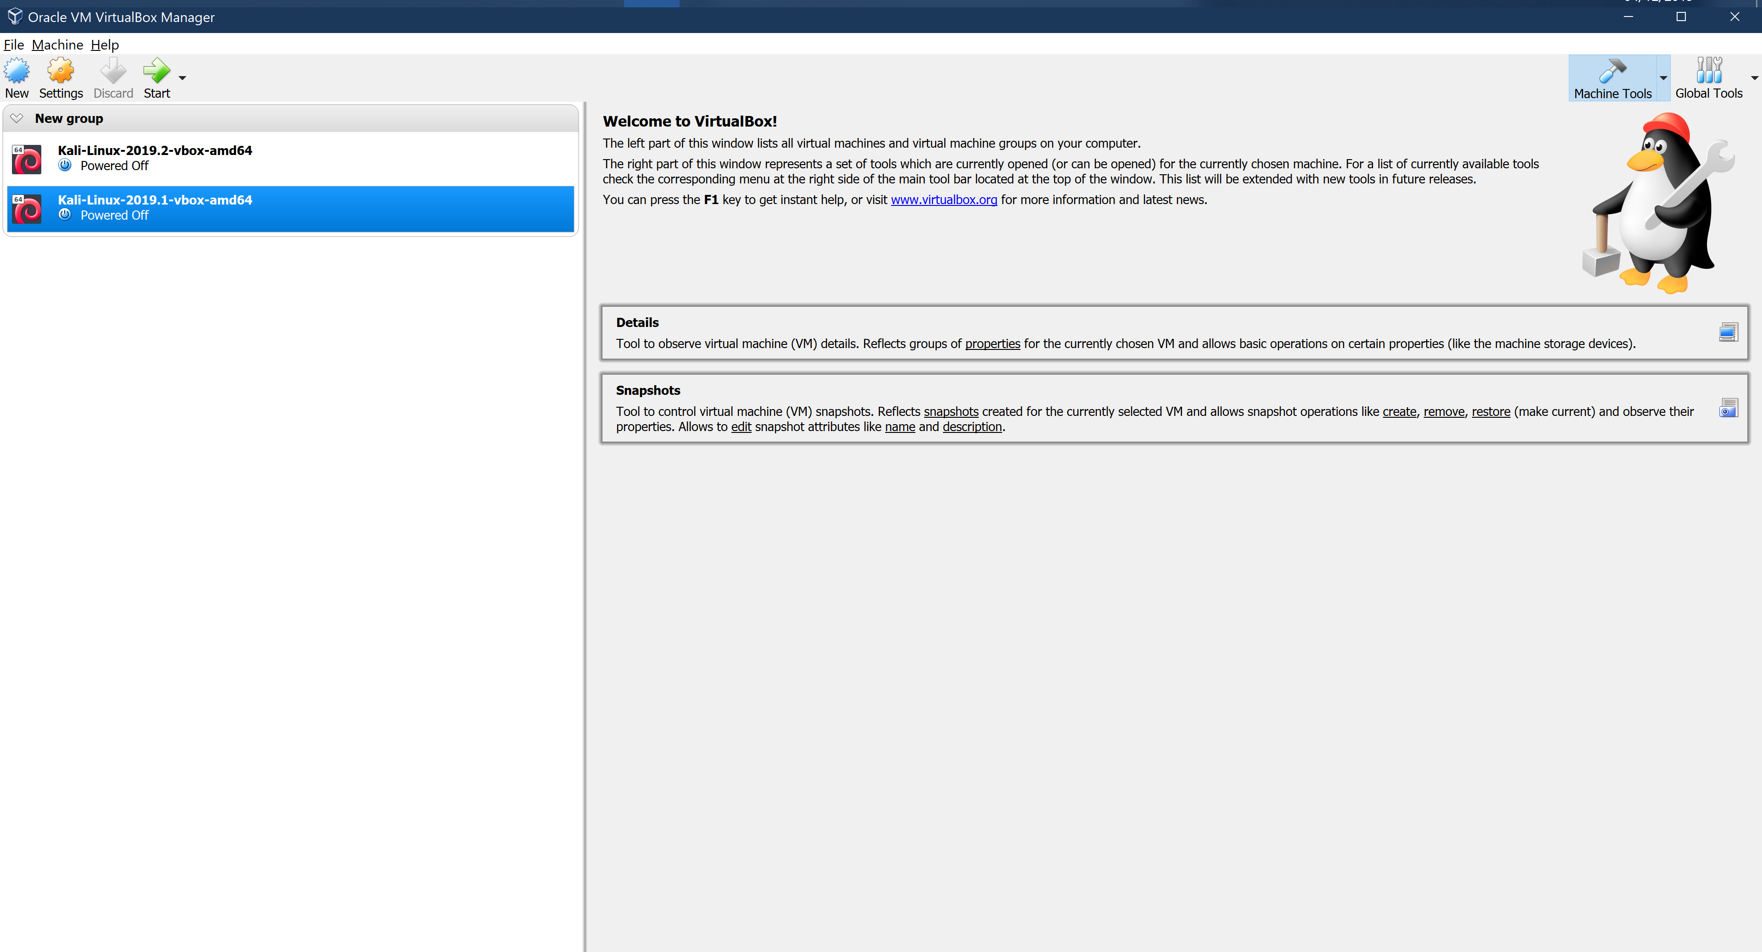

As you can see. This is what was displayed once it was imported.

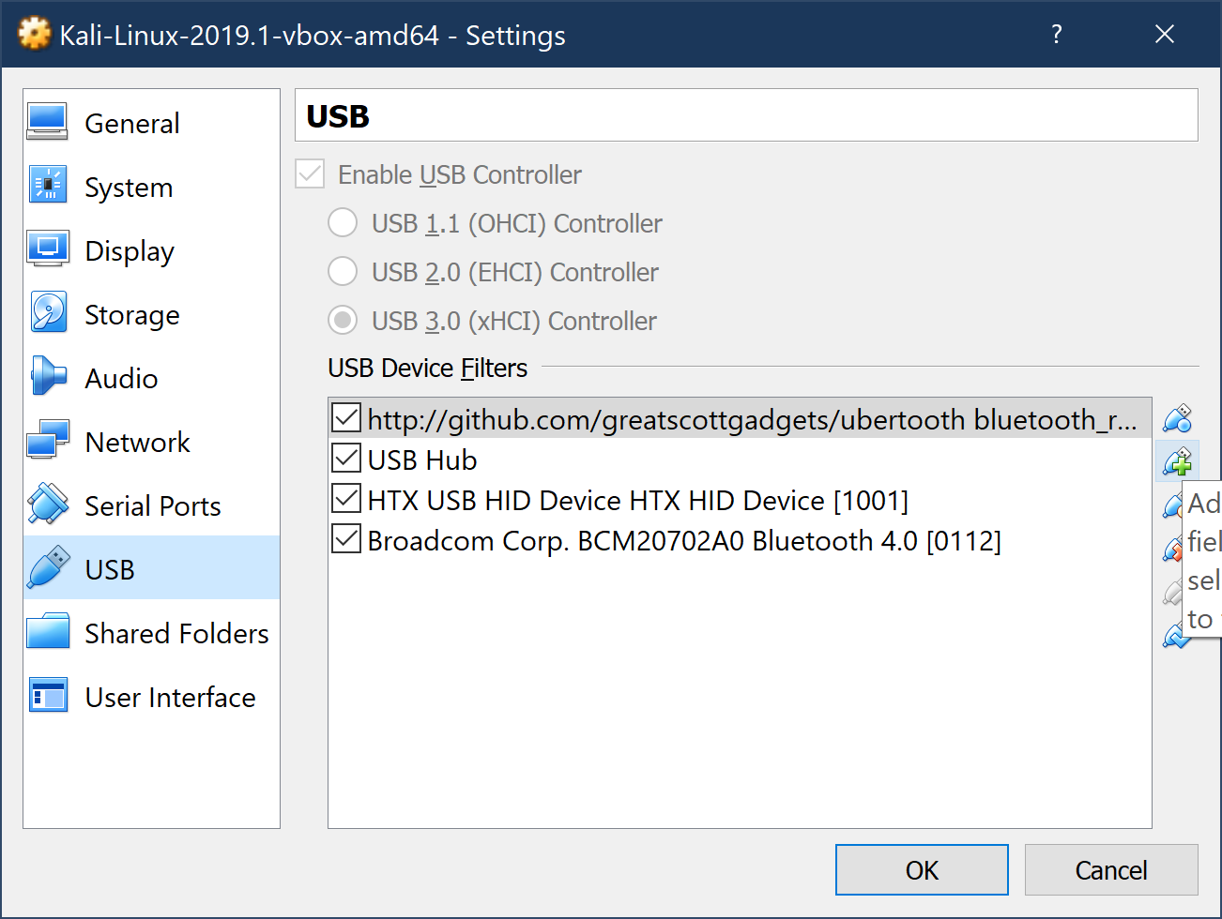

I then setup the USB devices so that the Virtual machine could always see them when they were plugged into my ports.

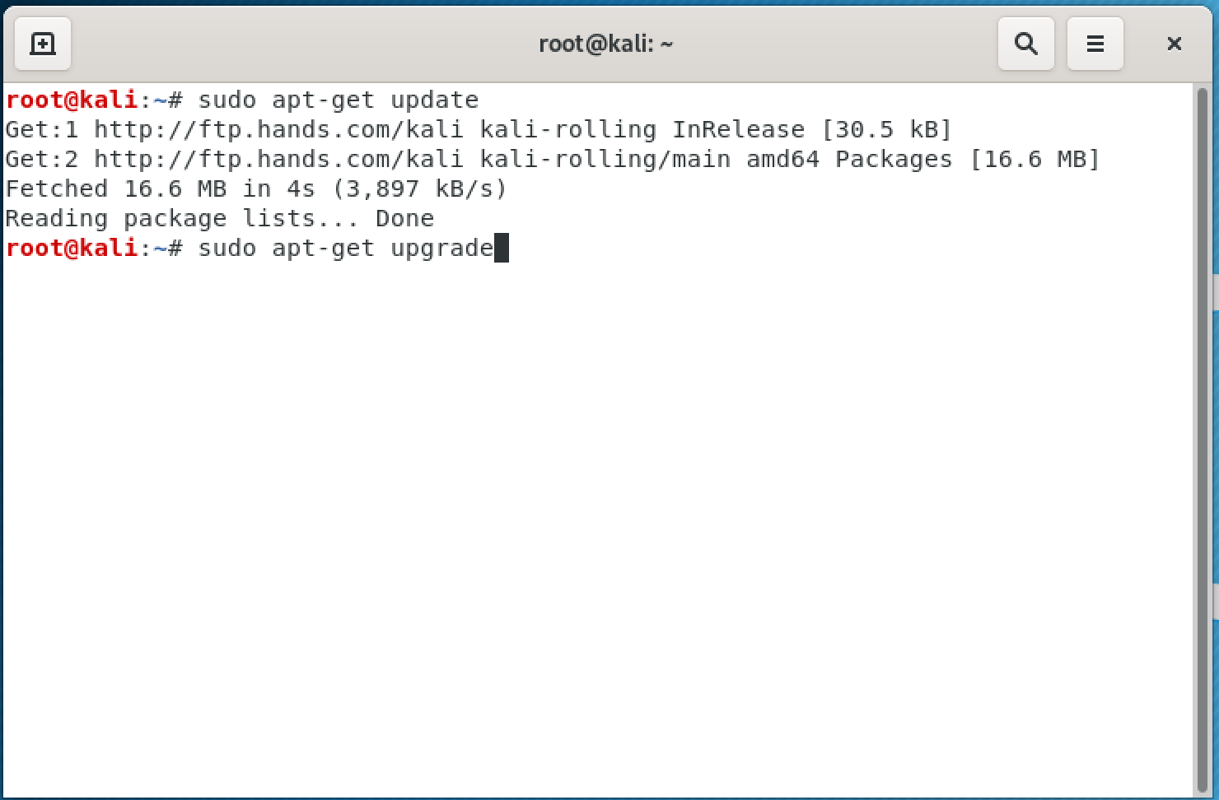

Once I was logged in, I opened a terminal and ran the two commands to update and upgrade the system.